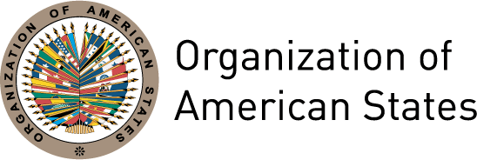
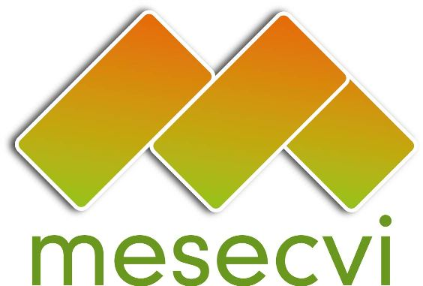

MESECVI Communiqué 01/2012-EN

Indigenous women demand equal access to justice in cases of violence

Media Contact: Hilary Anderson, Specialist, Inter-American Commission of Women
handerson@oas.org, 1-202-458-3306

[Washington, D.C., November 7th 2012] The Follow-up Mechanism to the Belém do Pará Convention (MESECVI) will host a Regional Forum on Indigenous Women and the Inter-American Justice System on November 12th 2012, in collaboration with UN Women and the Secretariat of External Relations of Mexico.

With a view to its elimination, the Inter-American Convention for the Prevention, Punishment and Eradication of Violence against Women (Belém do Pará Convention) establishes the obligation of States to implement just and effective legal procedures for women that have been subjected to violence, as well as the legal and administrative mechanisms necessary to ensure that women have real access to compensation, reparation or other measures.

Fifteen years after the entry into force of the Belém do Pará Convention, little progress has been made in the implementation of these provisions. The Inter-American Commission of Human Rights (IACHR) finds that the majority of cases of violence against women are not formally investigated, judged or sentenced by justice administration systems. This reality promotes a culture of impunity and tolerance for violence against women, as well as growing mistrust of the justice sector among women, which is further aggravated by the ethnic and socio-economic discrimination faced by many indigenous women.

In its Second Hemispheric Report, MESECVI highlights a number of persistent obstacles faced by indigenous women in terms of their access to justice, including an inadequate number of installations that attend women who wish to file complaints; the need to strengthen the capacities of justice sector personnel to address violence against women; the lack of protocols for the care of women victims of violence, particularly in indigenous languages; the use of conciliation or other measures of compromise between the aggressor and victim; and the lack of resources and mechanisms to implement effective protection measures.

This Forum will feature diverse experiences in the defense of indigenous women’s rights within the context of the inter-American human rights system. Speakers incluye: Inés Fernández Ortega and Valentina Rosendo Cantú of Mexico; Martha Sánchez Nestor, Coordinator of the Alliance of Indigenous Women of Central America and Mexico; Nina Pacari, Minister of the Constitutional Court of Ecuador; Mirna Cunningham Kain, a women’s and indigenous Rights activist from Nicaragua; Otilia Lux de Cotí, Director of the International Formum of Indigenous Women; and Alejandro Negrín, Director General for Human Rights and Democracy of the Secretariat of External Relations of Mexico.

The main objective of the Forum is to bring greater visibility and attention to the issue of access to justice for indigenous women, as well as foster the exchange of regional experiences and good practices. The event is part of the MESECVI Experts’ work to identify the main obstacles faced by women victims of violence, in particular those that are subjected to multiple forms of violence.

The Forum will begin at 9:00am local time in Mexico City, at the headquarters of the Secretariat of External Relations of Mexico (José María Morelos y Pavón Hall).

_______________________________________

The Organization of American States (OAS) is the world’s oldest regional organization, dating back to the First International Conference of American State (October 1889 to April 1890). It was established in 1948 with the aim of achieving among the States of the Americas “an order of peace and justice, to promote their solidarity, to strengthen their collaboration, and to defend their sovereignty, their territorial integrity, and their independence.” The OAS prioritizes four pillars - democracy, human rights, security, and development – that support each other and are intertwined through political dialogue, inclusiveness, cooperation, and legal and follow-up instruments that provide the OAS with the tools to maximize its work in the Hemisphere.

Established in 2004, the Follow-up Mechanism to the Belém do Pará Convention (MESECVI) was created as an independent, consensus-based system to examine the progress made by States in fulfilling the objectives of the Inter-American Convention on the Prevention, Punishment and Eradication of Violence against Women (Belém do Pará Convention).
For more information, visit MESECVI at: http://www.oas.org/en/mesecvi

